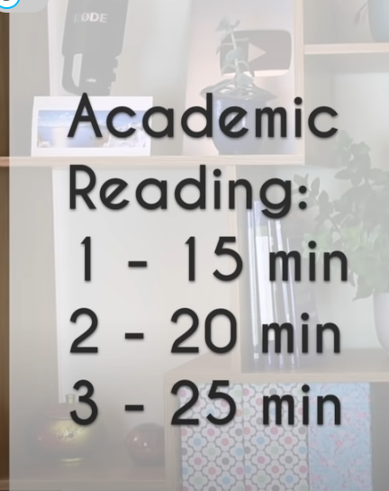

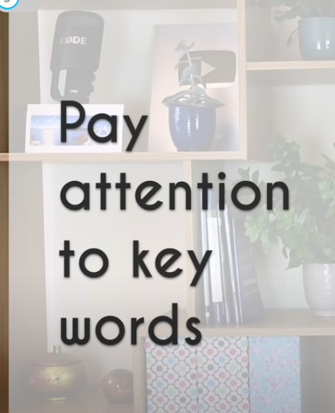

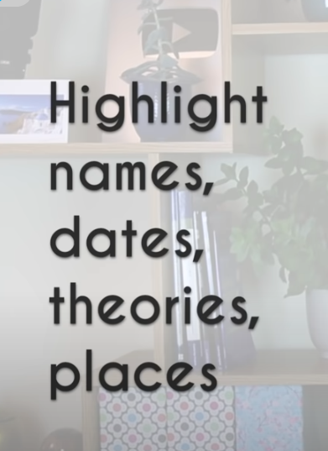

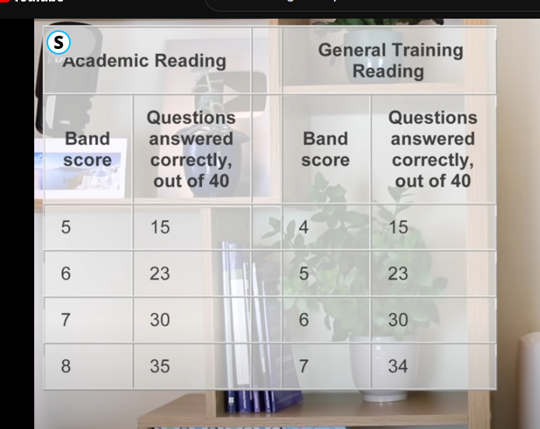

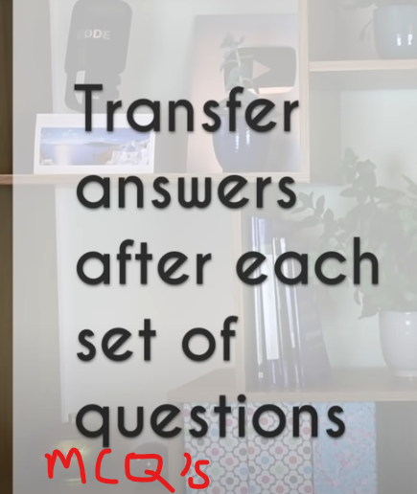

* 40 questions -> 3 longer
* I would say Read x3 questions first then start skimming through the paragraphs and when you feel you reached a point where the answer is somewhere hidden its time to slow down the pace.
* Read the question and highlight the keywords and what do they mean, look for the keywords synonyms in the paragraph
* Ignore irrelevant content that doesn’t relate with the keywords
* Most of the questions order follow the passage

True – False – Not Given

* There must be all 3 types of answers used in this exam

